COST IC0604 MC and WGs meeting. April 1-2, 2011
Meeting place:
Innovation Center (ICEF), Faculty of Electrical Engineering (ETF), University of Belgrade
http://www.etf.bg.ac.rs/, http://www.icef.etf.rs/
Pavilion I “Rasovic”, Room 25/1st fl.
Bulevar Kralja Aleksandra 73, 11000 Belgrade
Hotels, maps and useful information
Prof. Branimir Reljin, Mob. +381-63-252482
# | Hotel | Contact | Single room | Double room | Web site
1. | Union  3* | +381-11-3248-022  Kosovska 11 | 37e (33e weekend rate) | 59e (56e weekend rate) | http://www.hotelunionbelgrade.com/  wireless free of charge
2. | Park  3* | +381-11-3640-385  Njegoseva 4 | 40e (54e comfort room) | 68e (86e comfort room) | http://www.hotelparkbeograd.rs/  wireless free of charge
3. | Royal  3* | +381-11-2626-426  Kralja Petra 56 | 45e, 40e, 35e (depending on room category) | 57e, 56e, 50e (52e, 48e, 40e single use) | http://www.hotelroyal.rs/
4. | Majestic 4* | +381-11-3285-777  Obilicev venac 28 | 59e (50e weekend rate) | 103e, 83e single use (weekend rate: 70e, 60e single use) | http://www.majestic.rs/  wireless free of charge
5. | Palace  4* | +381-11-2637-222  Toplicin venac 23 | 60e  (54e weekend rate) | 87e (79e weekend rate) | http://www.palacehotel.rs/  wireless free of charge
6. | SlavijaLux 4* | +381-11-244-1120  Svetog Save 2 | 75e | 93e | http://www.slavijahotel.com/  wireless free of charge
7. | Prag  3* | +381-11-361-0422  Kraljice Natalije 27 | 78e (71e weekend) | 99e (90e weekend) | http://www.hotelprag.rs/  wireless free of charge
8. | Excelsior 3* | +381-11-323-13-81  Kneza Milosa 5 | 85e | 99e (90e single use) | http://www.hotelexcelsior.rs/  wireless free of charge
Tourist tax (around 2e) usually not included in the price.
Hotel info: http://www.tob.rs
9. Tram station “Main railway station”. Lines no. 2 and 7.  10a. Tram station no. 7 “Hotel Metropol” or “Pravni Fakultet”.  10b. Tram station no. 2 “Vukov spomenik”. | 11. Bus station no. 72 “Zeleni venac” (bus 72 from/to airport).  12. ETF, Pavilion I, ICEF buildings, Bul. Kralja Aleksandra 73.  13. Intl. Airport “Nikola Tesla”, Beograd (approx. 20 km from the city)

Map of Belgrade with public transport information is available at: http://www.planplus.rs/?lang=en-us
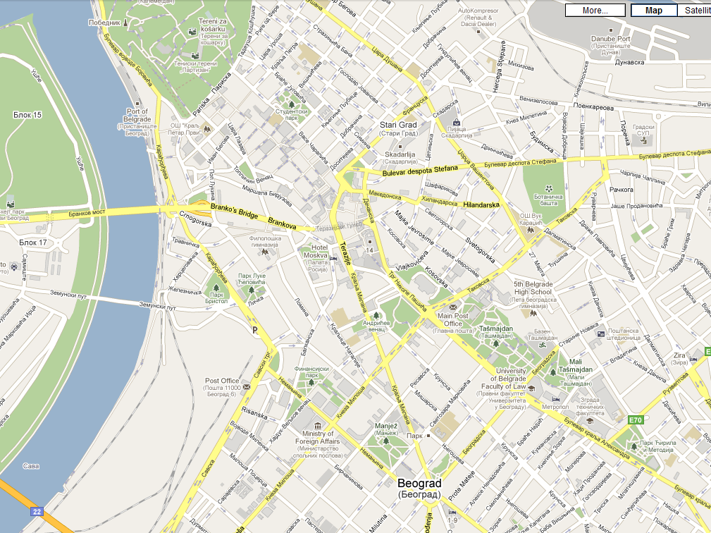
1
2
3
4
5
6
7
8
9
10a
12
10b
11
General Locations
From-to airport
From-to airport
Transportation from-to airport “Nikola Tesla”
You can use official taxi. Take a voucher at the info desk, at arrival terminal (see also “Relevant Information” pages of this document). The price to the center of the city (all the hotels and buildings labeled on our maps) is 1500 RSD (approx. 15 EUR). Serbian Dinars (RSD) are accepted. Exchange office at arrival terminal is available.
You cau use even public transportation (bus line 72) from-to airport “Nikola Tesla”
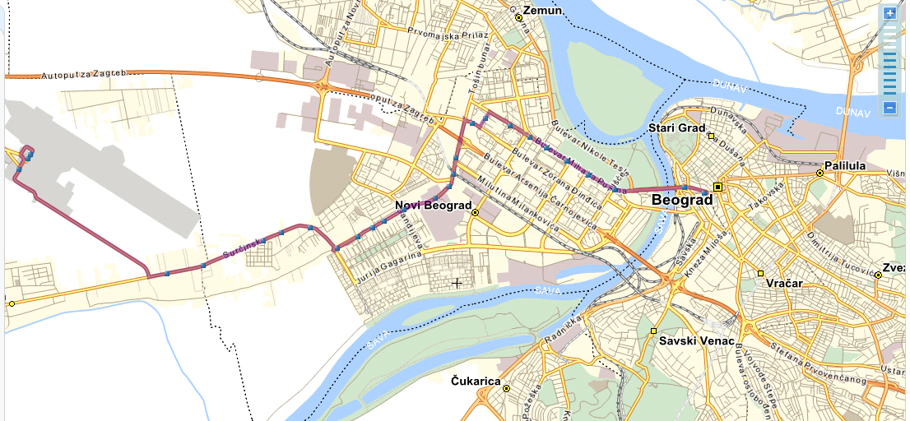
13
11
12
Legend
11. Bus Station „Zeleni venac“ 12. ETF, ICEF buildings 13. „Nikola Tesla“ Airport
------ Bus line 72

Meeting place

Meeting place: Pavilion I “Rasovic”, 1st floor, Room 25
Innovation Center (ICEF), Faculty of Electrical Engineering (Elektrotehnicki fakultet), Bulevar Kralja Aleksandra 73
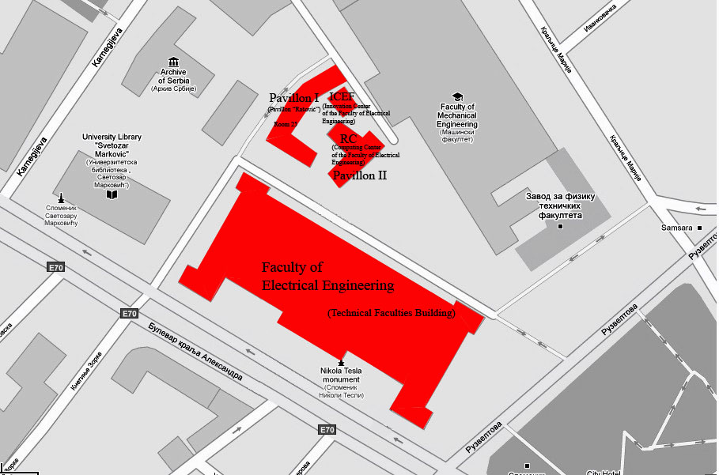
10b
10a
12
Meeting place
Note: Station 10a is slightly out (on the left) of this map.

Relevant Information
Time Zone
Belgrade and Serbia are located in the Central European time zone region: GMT +1 and/or GMT +2 as of the last week in the third month (March) until the Saturday prior to the last week of the tenth month (October).
Electricity
As in most cities of Continental Europe, the electricity voltage in Belgrade is 220V. Electrical outlets are standard European.
Water
Tap water in Belgrade is safe to drink.
Currency
The official tender in Serbia is dinar, abbreviated RSD. Money may be exchanged in all banks and post offices, as well as in authorized exchange offices. Dinar is issued in denominations of 10/20/50/100/200/500/1000/5000. Approximately (January 17, 2011) middle exchange rate is 1EUR = 105 RSD.
The current exchange rate may be checked on the website of the National Bank of Serbia (http://www.nbs.rs)
The area code for Belgrade in national traffic is 011
The area code for Serbia in international traffic is 381. To call Belgrade from abroad please dial the appropriate international code, e.g. 00 (or +), then dial the area code for Serbia 381 and the area code for the city (without the initial 0)11. To call a foreign country from Belgrade, please dial the international code 00, then the country area code, the city area code (without 0) and, finally, the telephone number of the subscriber.
Important Telephone Numbers (dial first +381-11)
Police – 92
Fire-fighters – 93
Ambulance – 94
Time – 95
AMSS road assistance – 987
Weather information – 9823
Public Telephone Booths
Public telephone booths (Halo govornice) are activated by Halo cards worth RSD 200 or 300, each offering a free call credit of RSD 15. The sales price is written on the card, which is also the value of the credit for making calls. Halo cards may be purchased on kiosks, post offices and in retail stores.
Public parking
Parking in Belgrade is organized according to zones. Parking in the first zone, marked by the color red, is allowed for a period of one hour. Parking in the second zone, marked by the color yellow, is allowed for a period up to two hours. Parking in the third zone, marked by the color green, is allowed for a period up to three hours. Parking may be paid at the machine on the spot at a number of parking spaces. Parking may also be paid by cell phone: type an SMS with the number of the car license plate (without space) and send it to 9111 for parking in the first zone; 9112 for parking in the second zone or to 9113 for parking in the third zone. Parking may also be paid by means of a parking ticket which may be purchased in most kiosks – fill in the parking ticket and place it in a visible spot in your car windshield.
There are six public garages in Belgrade. For more information on parking see www.parking-servis.co.rs/en
Taxi rates
Service  (prices in RSD) | Tariff 1  (06:00-22:00) | Tariff 2  (22:00-06:00,  Weekdays and Holidays) | Tariff 3  (Outside City) | 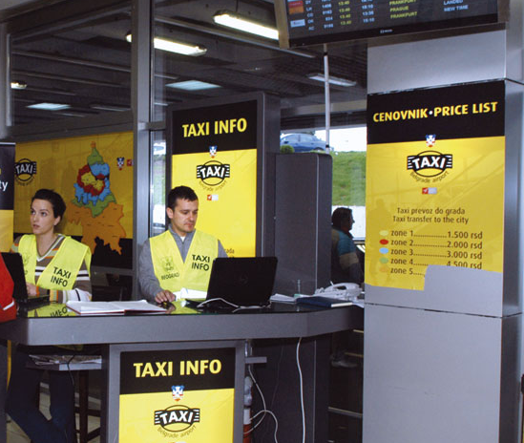  Taxi vouchers with fix taxi fare can be obtained from the info stand at the arrival terminal of airport “Nikola Tesla”. The price to the center of the city (all the hotels and buildings labeled on our maps) is 1500 RSD.
Start | 140 | 140 | 140
Price Per km | 55 | 70 | 110
Waiting Per Hour | 750 | 750 | 750
Standard price within the city (up to 5 km) is about 500 RSD.

Public Transport

Tickets are valid for one continuous ride in trams and buses. Single tickets can be bought at newsstands/kiosks and in vehicles.

Bus from/to airport line 72
Route: Belgrade "Nikola Tesla" Airport – “Zeleni venac” Square (Belgrade City) - 05:20 until 00:00 hours; departs every 32 minutes
Route: “Zeleni venac” Square (Belgrade City) - "Nikola Tesla" Airport - 04:40 until 23:40 hours; departs every 32 minutes
Approximate travel time: 30 - 40 minutes depending on the traffic
Ticket price for 1st and 2nd zone: 80 RSD (if bought on newsstand/kiosk), 120 RSD (if bought in the bus)
Tram lines 2 and 7
04:10 until 23:30; departs approximately every 10 minutes
Ticket price for 1st zone: 50 RSD (if bought on newsstand), 100 RSD (if bought in the tram)
Public Transport Info: www.gsp.rs

