Second Announcement – Information
“1st European Scanner Contest (ESC)”
-Berlin-Brandenburg-Vilnius-
T. Schrader^{1,2}, P. Hufnagl¹, M.G. Rojo³, A. Laurinavicius⁴
¹Institut für Pathologie, Charité – Universitätsmedizin Berlin, Germany, ²Fachhochschule Brandenburg, Brandenburg, Germany, ³Servicio de Anatomia Patologica, Hospital General de Ciudad Real. ⁴National Centre of Pathology, Vilnius, Lithuania

Current Status
The number of participating vendors is six. Most of the relevant scanner producers for the European market take part.
There have been asked a lot of questions, and a lot of comments and proposals by various people have been made. Thank you for this input. We made several modifications. The overall goal of the contest is to speed up the introduction of virtual microscopy into daily practice.
We have been asked for several other disciplines including z-stack scans, overall usability and GUI, image analysis algorithms, viewing option, applications, PLIS/ PACS integration. It is planned to offer participation in such disciplines in the future. Now, we focus on quality, robustness and speed in the current contest.

Costs
We tried to keep the running costs of the contest as low as possible. Additionally, we asked for sponsoring from different sides and got some. Nevertheless, we need to share the remaining costs to a participation fee for the contest:
Participation fee: 1.500,- Euro
This fee includes the room fee, tables, chairs, power, Internet access via WLAN and catering.

Room conditions
We will have one room with 200 m². The room will be separated by dividers of 1,90m height and 1,30m width into boxes for each participant. We need to know the size of the table area you need and the weight of the system.
It is possible to order exhibition stand construction boards of 2,30m height and 1,00m width alternatively. This would generate an additional fee of € 45,00 per running meter.
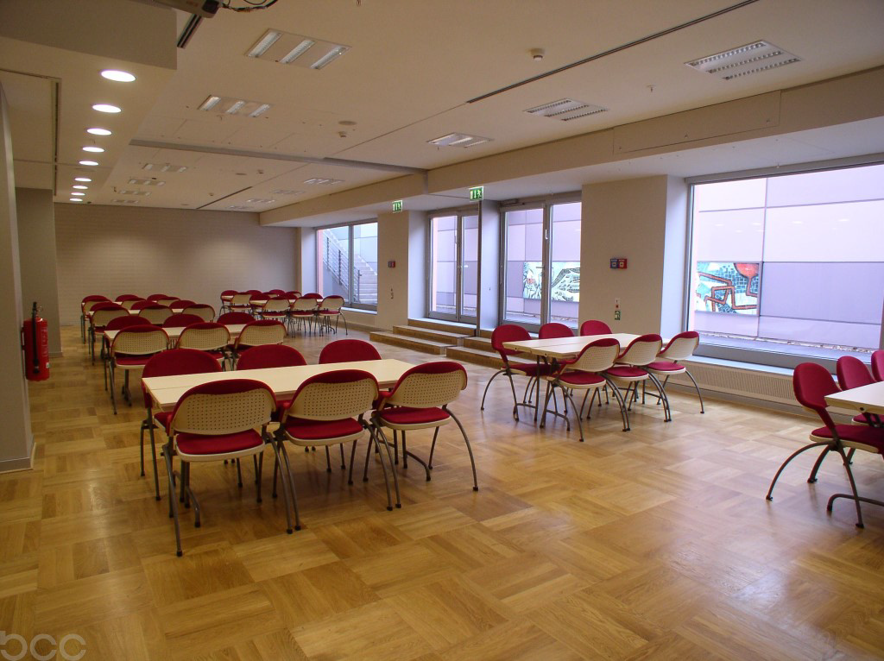
Fig. 1: Room for the 1st European Scanner Contest without installation of boxes.

Options to deliver the system
You have the possibility to send or deliver the scanner to the following address:
BCC/ Herrn O. Höppner
Woche der Pathologie/ Scanner Contest
Alexanderstr. 11
D-10178 Berlin
The scanner may arrive at BCC Thursday May 20th, Friday 21th and Saturday 22nd between 8 a.m. and 6 p.m. or Tuesday 25th between 8 a.m. and 10 a.m. Delivery on Whit Sunday 23rd and Whit Monday 24th cannot be arranged.

Schedule & Locations
The contest room will be open between 8 a.m. and 6 p.m. There will be a referee available during the test days Tuesday 25th and Wednesday 26th.
1. Delivery of the scanners
Delivery of the scanners will be possible Thursday, 20th, Friday 21th, Saturday 22nd or Tuesday 25th
2. Assembling of the system
Assembling of the system will be possible Saturday 22nd or Tuesday 25th between 8 a.m. and 11 a.m. Please indicate your delivery and assembling date in the questionnaire.
3. Scanner contest
Scanner contest will run on Tuesday 25th and Wednesday 26th. Official start of the contest is 11 a.m. Nevertheless participants who assembled their system already on Saturday 22nd may start at 8 a.m. with the scan of the test series under supervision of referees.
4. Evaluation
Evaluation will take place parallel to the contest, during the conference and after the contest. First results will be presented already on the conference.
5. Additional scanning option
We have been asked from several sides if there is a possibility to get a second chance if technical problems appear which cannot be fixed in time. So we will offer an additional possibility to scan parallel to the running conference.

Evaluation of the results – algorithms
Time
Time measurements are performed always under supervision of referees. We use the following two ways:
- Measurements by the referee with stop watch
In cooperation with the responsible person of each vendor, referees will record the overall scanning times manually.
- Analysis of the log files
Parallel, optional and in cooperation with the vendors the log files of the scanner system are analyzed.

Image Quality
Image quality may be analyzed in different ways:
- Manually by pathologists or other users,
- Automatically by computer programs
Both ways have advantages and disadvantages. We do both. Under the term image quality we understand in the current contest: correct number of particles detected and scanned, amount of unfocused regions, stitching artifacts, overall image quality at given magnification
Results of the discussion with the vendors:
Based on several discussions the following facts have to be accepted:
- Only a few vendors have an API for the access to their WSI format. Vendors which have no API available have an API under development. All vendors are willing to offer their API for measurement and contest purposes.
- JPEG2000 is provided only by some of the vendors and may not be used for comparison at the moment.
- With respect to features of the sensors the resulting size of the pixels differs from vendor to vendor. This results in different resolutions for the same objective. WSI should be compared on the original size. An alternative is downsizing to the minimal resolution.
- The direct use of the viewers of the vendors for the comparison by pathologists has two disadvantages: Firstly the loss of anonymity of the vendors, secondly possible shift/bias to evaluation of usability instead of image quality.
- Vendors are interested to show the functionality of their viewers for the test slides. So we will provide a web server which offers viewing of all WSIs scanned by each vendor with the vendors own viewer. This server will be active after the contest until the next contest. This will take place on a formal agreement, which is under negotiation.

Manual analysis by pathologists
Based on the results of the discussion above we prepare a comparison of the image quality based on a series of field of views of identical areas of the slides. These areas are marked by a pathologist as diagnostically relevant areas (between two and five for each WSI).
The referees will use the original viewer of the vendor running on identical workstations and monitors.
The field of views for identical areas are compared and evaluated by a custom made application which offers parallel viewing and ranking by drag and drop. A committee of pathologists will evaluate these images. Furthermore, pathologists attending the conference will have the possibility to contribute to the contest by participation. Several identical workstations will be offered.
A second form of evaluation will be possible if all vendors offer their APIs for the contest in the future.
Automatic analysis:
- Sharpness:
Sharpness will be measured by tiling the WSI into tiles of minimal 128x128 pixel. For each tile sharpness features (filter) are determined. Based on the filter values a sharpness level is attached to the tile (sharp, not sharp, out of focus), A mask over the WSI is generated and evaluated. Three values are generated, the overall amount of sharp tiles, the amount of areas out of focus and the mean focus level.
- Stitching:
Stitching is analyzed by orthogonal and vertical correlation filters which compare lines of one, two and three pixels difference. Stitching problems are described as length of lines with stitching problems with respect to the measured area for the analyzed WSI.
- Unrecognized regions:
Unrecognized regions are measured in number and size. Therefore the number of detected particles and the total area are compared. As standard a manually supervised mask of particles is used. Particles are known by contour and position.
Evaluation and presentation of results.
- There are several modes under discussion and in preparation - please indicate your favorite mode in the questionnaire:
  - Mode I - Categorization: Results are separated into the categories A – very good, B - good and C acceptable, D- insufficient,
  - Mode II - Point System: The results are transferred into a point system which ranges for single descriptors between 0 and 100.
  - Mode III – Ranking: Results are ranked and ranks as well as original results are presented
  - Mode IV – Ranking only: Results are ranked and only the ranks are presented.
- Participating companies may decide which results should be part of the contest and which not. Therefore they will get an Excel sheet with all results which have been made anonymous.

General rules
- Every participating company can freely decide to take part in any of the different disciplines of the contest.
- All slides are provided by the organizing committee.
- The contest room is supervised by referees who organize the turnaround of the slide series and perform time measurements.
- Participating companies may use maximal 2 different scanners. These scanners may be identical or of different type. If different types are included results will be analyzed and displayed separately.
- Evaluation results can be reviewed/ commented on by participants.

Questionnaire
- Delivery date and time, if already known:
- __________________________________________DD MM YYYY, HH MM, a.m./ p.m.
- Number of scanners to take part in the contest: one two
- Number of tables needed: ______
- Minimal size of the table for the scanner __,___m width, ___,___m height
- Weight of the scanner: _______kg
- Other power supply than 220 Volt
- We need exhibition stand construction boards of 2,30m height and 1,00m width.
(€ 45,00 per running meter). We order ____ running meters. Please send me an invoice.
- Please indicate the model you prefer (more than one tick possible):
  - Mode I - Categorization: Results are separated into the categories A – very good, B - good and C acceptable, D- insufficient,
  - Mode II - Point System: The results are transferred into a point system which ranges for single descriptors between 0 and 100.
  - Mode III – Ranking: Results are ranked and ranks as well as original results are presented
  - Mode IV – Ranking only : Results are ranked and only the ranks are presented.

Hints
- To prepare the relevant screenshots vendors must install their own viewer on a Windows XP 32 bit PC. Please be prepared for such an installation.
- Image files (WSI) are transferred via USB hard drive. Please prepare minimal one USB 2.0 hard drive.
- Available power supply is German socket, 220 Volt. Please bring adapters if necessary.
- We need the API from each vendor as early as possible. This is the basic software for the automatic evaluation – which will take place after the scanner contest.

